Theory
Big O Notation
Big O notation is used to measure the efficiency of an algorithm by describing how its execution time grows as the input size increases. It helps compare different algorithms and choose the most efficient one.

Linear Search
Linear Search checks each element one by one until the target element is found or the list ends. It works on both sorted and unsorted data.
Time Complexity:
- Best Case: O(1)
- Average Case: O(n)
- Worst Case: O(n)

Binary Search
Binary Search works only on sorted data. It repeatedly divides the search space into two halves until the target element is found.
Time Complexity:
- Best Case: O(1)
- Average Case: O(log n)
- Worst Case: O(log n)

OUTPUT

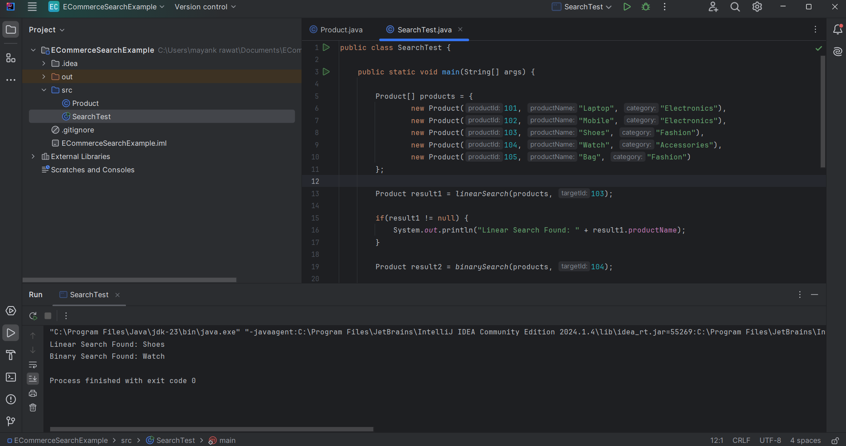
CODE
Product
public class Product {

int productId;
String productName;
String category;

public Product(int productId, String productName, String category) {
this.productId = productId;
this.productName = productName;
this.category = category;
}
}
SearchTest

public class SearchTest {

public static void main(String[] args) {

Product[] products = {
new Product(101, "Laptop", "Electronics"),
new Product(102, "Mobile", "Electronics"),
new Product(103, "Shoes", "Fashion"),
new Product(104, "Watch", "Accessories"),
new Product(105, "Bag", "Fashion")
};

Product result1 = linearSearch(products, 103);

if(result1 != null) {
System.out.println("Linear Search Found: " + result1.productName);
}

Product result2 = binarySearch(products, 104);

if(result2 != null) {
System.out.println("Binary Search Found: " + result2.productName);
}
}

public static Product linearSearch(Product[] products, int targetId) {

for(Product product : products) {

if(product.productId == targetId) {
return product;
}
}

return null;
}

public static Product binarySearch(Product[] products, int targetId) {

int low = 0;
int high = products.length - 1;

while(low <= high) {

int mid = low + (high - low) / 2;

if(products[mid].productId == targetId) {
return products[mid];
}

if(products[mid].productId < targetId) {
low = mid + 1;
}
else {
high = mid - 1;
}
}

return null;
}
}

